**SPRINT-3**

Team ID -- PNT2022TMID37201

Project Name -- IoT Enabled Smart Farming Application.

**Node RED Flow between Watson IoT and MIT App:**

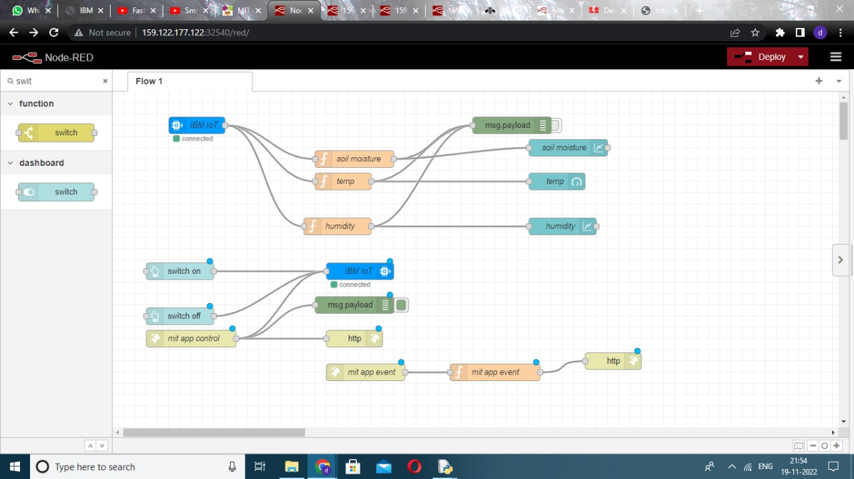

**SOIL PARAMETER MEASURMENT and SMART IRRIGATION SYSTEM:**

Parameters like temperature, humidity and moisture is generated randomly in IBM Watson IoT Platform and send to the MIT App through Node Red.

**Codes on the function nodes of NODE Red:**

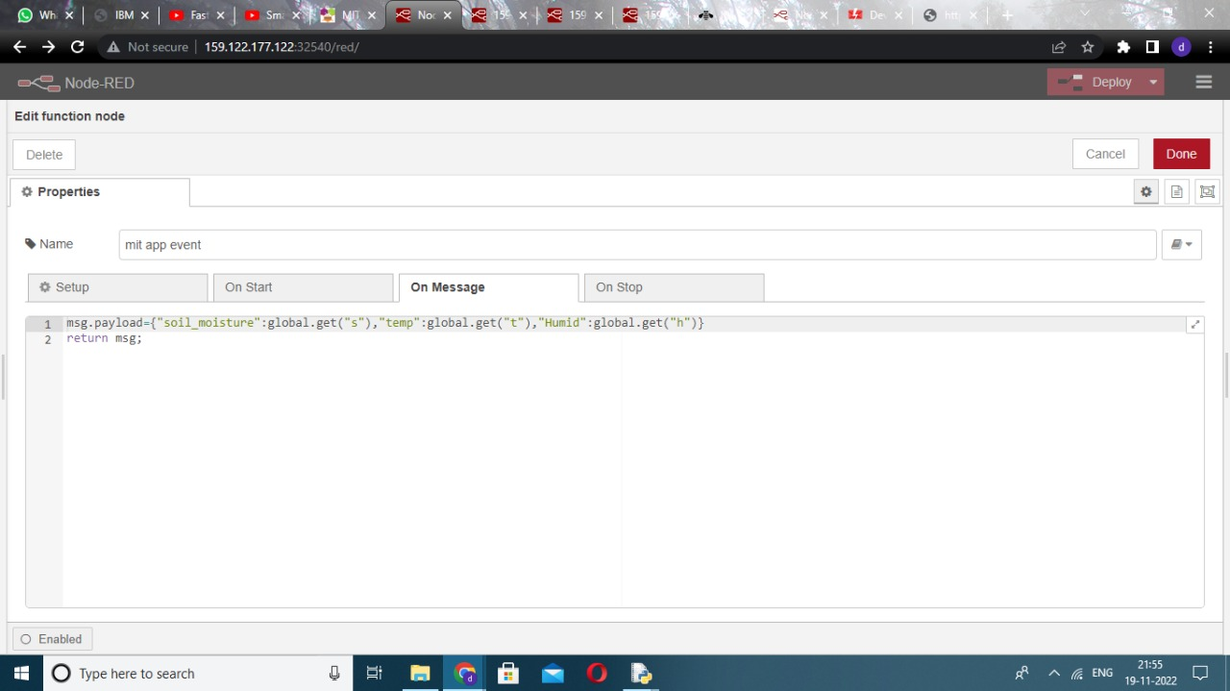

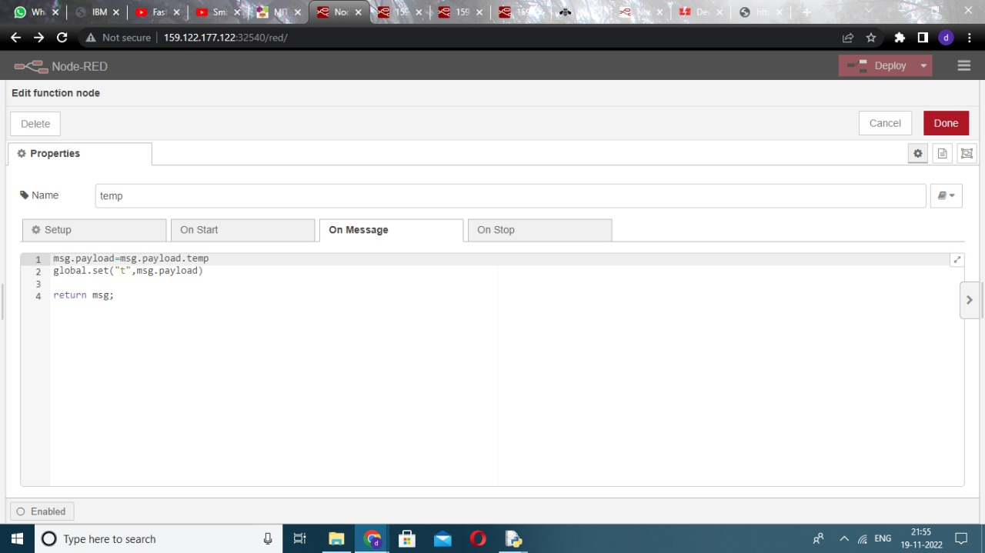.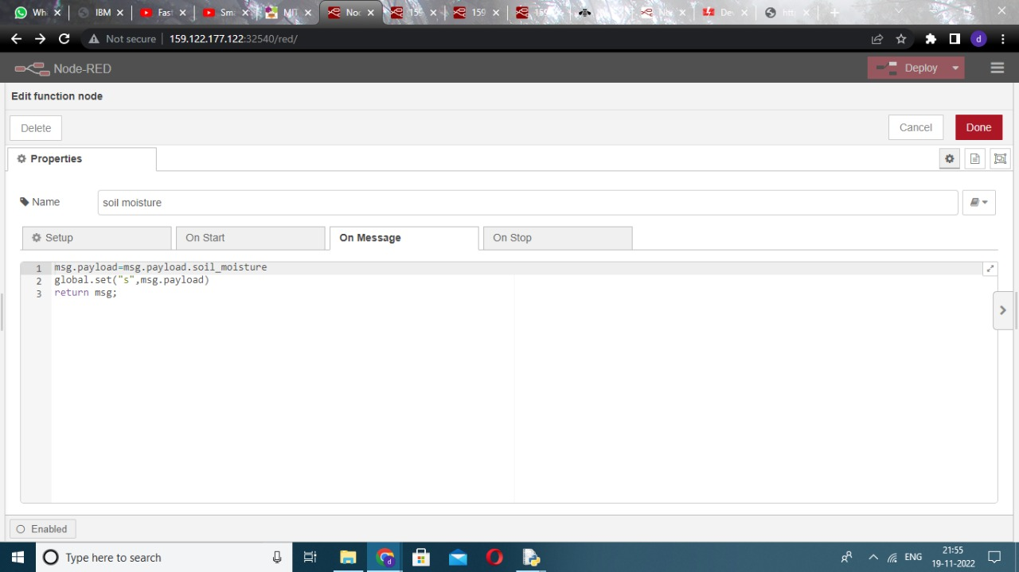

OUTPUT

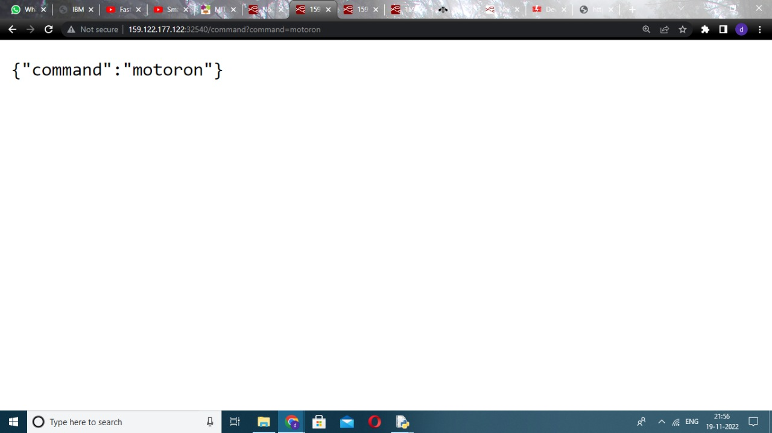

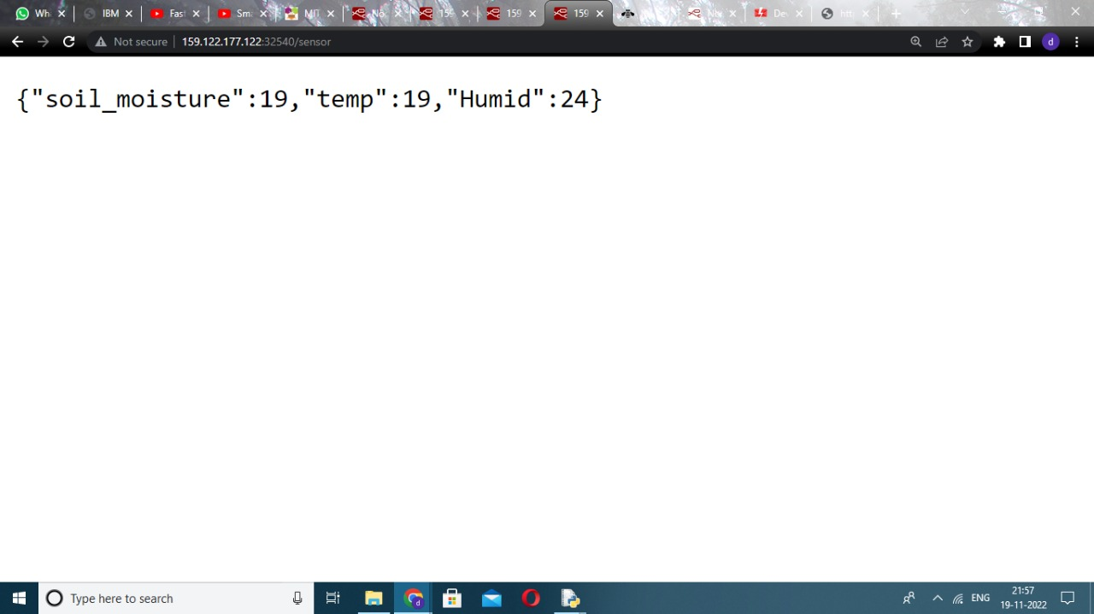

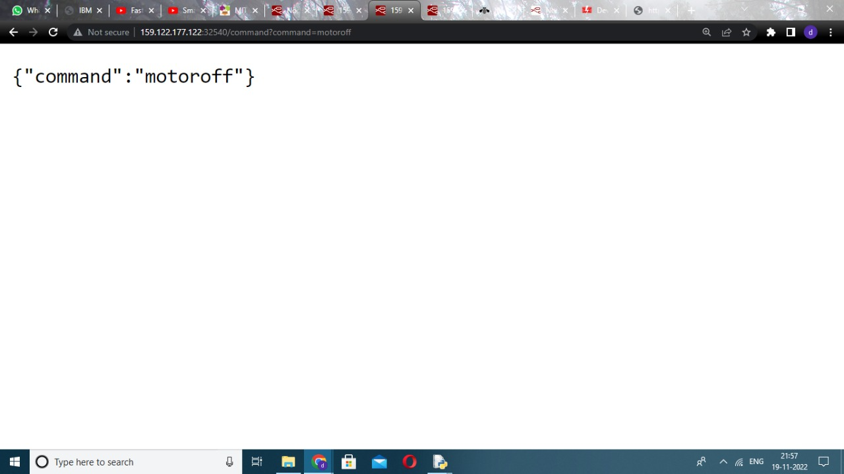

**SHOW THE TEMPERATURE, HUMIDITY, SOIL MOISTURE RANGE**

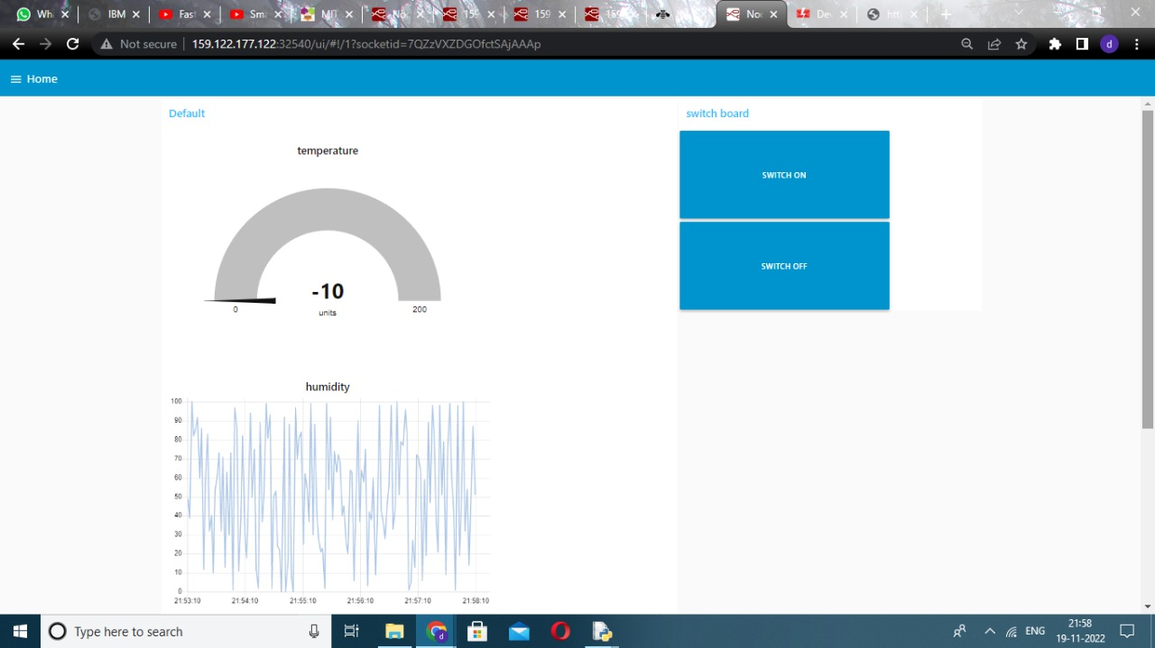

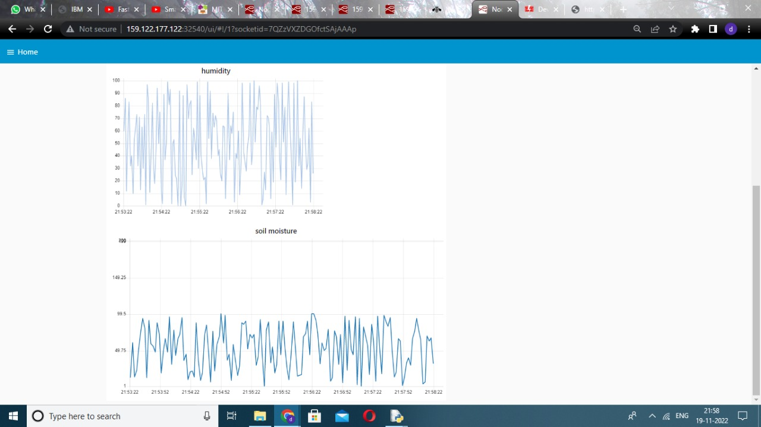

**SCREEN VISIBLE ON LAPTOP**

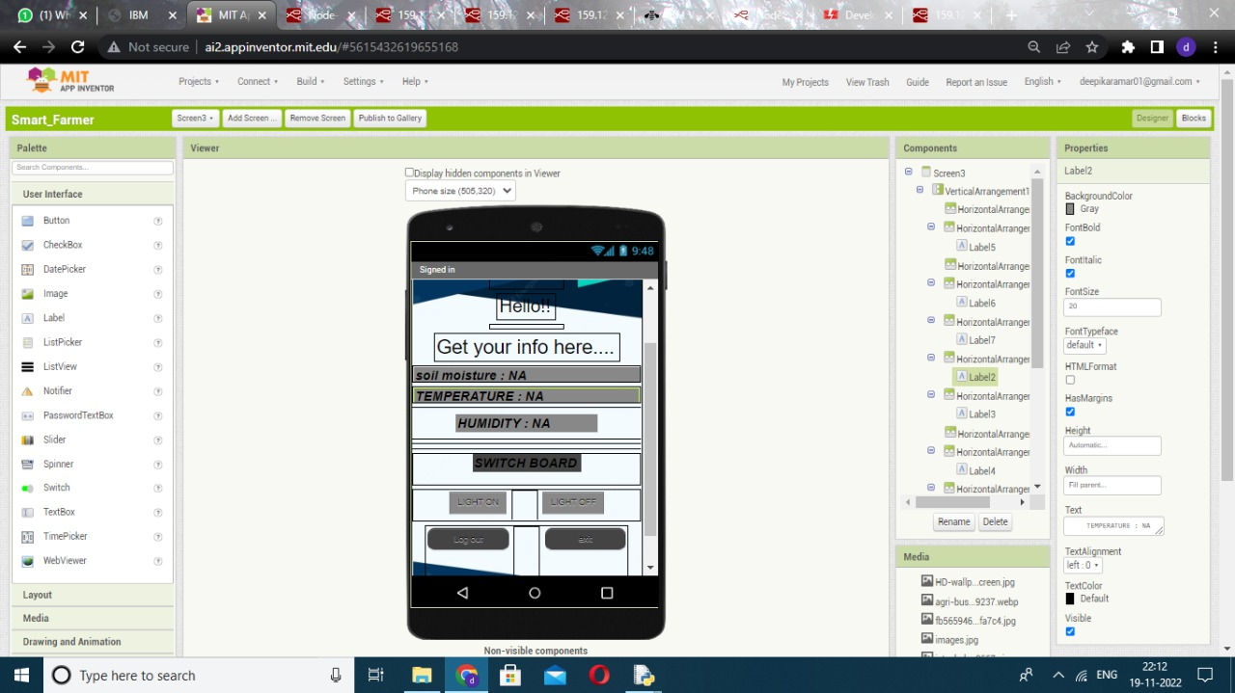

**BLOCK FOR THIS SCREEN**

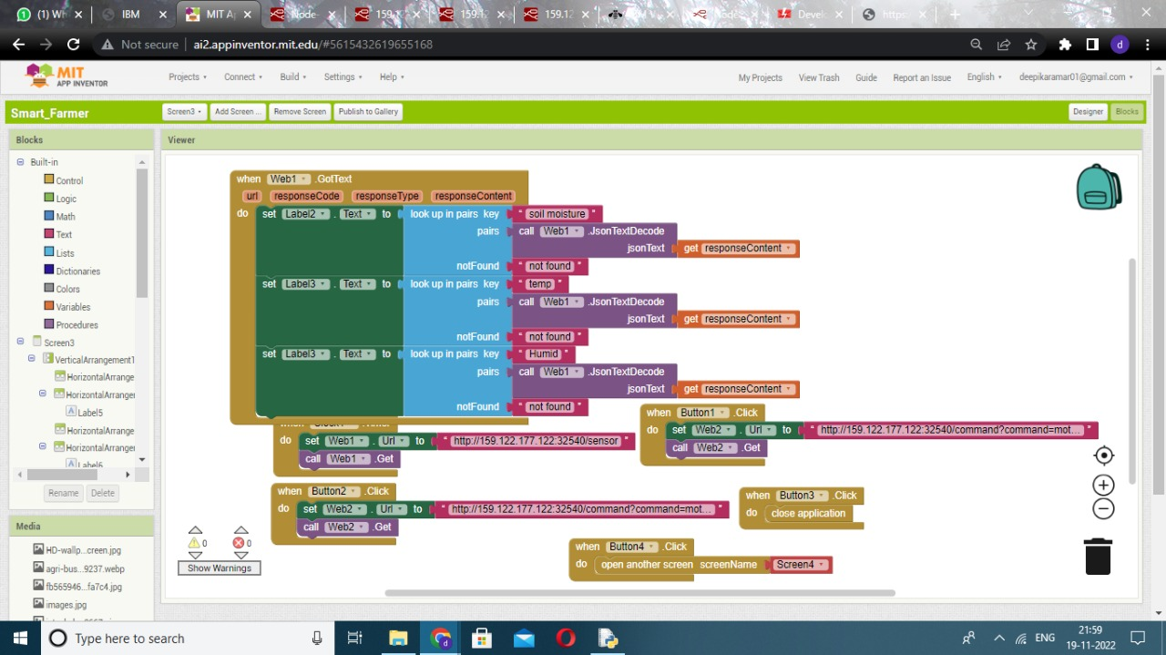



From this screenshots, the generated parameters are sent to NODE Red and viewed by user in User Interface. After the farmer saw the parameters, if they want to irrigate their farm, they only have to Turn ON and OFF the irrigation system through the MIT App.

The soil parameters values are displayed on APP generated from the IBM Watson IoT Platform. The command of Turning ON and OFF the motor is given by the farmers from the app and also send to the IoT platform.